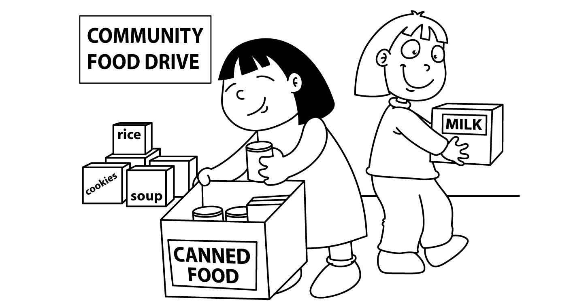

MONTH of NOVEMBER
Sunday | Monday | Tuesday | Wednesday | Thursday | Friday | Saturday
 | Toast  Juice/milk | Cheese & Crackers  Juice/Milk | Toast  Juice/Milk | Fruit & Yogurt  Juice/Milk | Toast  Juice/Milk | 1.
2. | 3.  Shelley  &  Barbara | 4.  Rowena | 5.  P.D  No School | 6.  Jodi | 7.  Audrey  &  Deanna | 8;
9. | 10.  Holiday | 11.  Holiday | 12.  Cathy  &  Pansy | 13.  Deneka  &  Ursula | 14.  Denise  &  Stephanie | 15.
16. | 17.  Verna  &  Nora | 18.  Tammy  &  Dorothy | 19.  Tracey  &  Diane | 20.  Jodi | 21.  Audrey  &  Deanna | 22.
23. | 24.  Shelley  &  Barbara | 25.  Rowena | 26.  Donna  &  Melissa | 27.  Cathy  &  Pansy | 28.  Denise  &  Stephanie | 29.
If you are unable to volunteer on the day you are scheduled, please make alternate arrangements with another volunteer.

